SIMATS ENGINEERING
ASSESSMENT TOOL 1
COURSE NAME: COMPUTER ARCHITECTURE COURSE CODE: CSA12
COURSE OUTCOME COVERED
CO1: Analyze the functional units of a computer system including CPU, memory, bus structures, and I/O components by examining instruction execution cycles, addressing modes, and performance metrics such as CPI, clock cycles, and benchmarking (BL4)
Assessment Tool Weightage: 40%
QUESTIONS:10 Total Marks:50
ANNEXURE A
APPLICATION BASED QUESTIONS
Code of Conduct:
I _________VARSHA.S(192511358)___________ (Name / Reg No) certify that this submission is my original work and that I have adhered to the guidelines specified for this assessment. I understand that any violation of academic integrity rules will result in disciplinary action.
Signature of the student:
ANNEXURE A
- A smart city surveillance system processes continuous video feeds from multiple cameras, where large volumes of data are transferred between I/O devices, memory, and CPU. During peak hours, the system experiences lag and delayed response in threat detection. Analyze how the interaction between CPU, memory, and I/O contributes to this issue, and explain how different bus structures (single-bus vs multi-bus) and improvements in instruction execution cycle can enhance system performance.
- A real-time stock trading application running on a processor executes millions of instructions per second, but users report delays in transaction processing during high load. The system has a high CPI due to frequent memory access and branch instructions. Examine how the fetch–decode–execute cycle impacts execution time in this scenario, and propose methods to reduce CPI and improve overall CPU performance using suitable architectural enhancements.
- An embedded system based on an 8085 microprocessor is used in an industrial temperature control unit, where sensors provide input and actuators respond accordingly. However, incorrect temperature readings are occasionally processed due to improper use of addressing modes in the program. Discuss how different addressing modes influence data access, identify possible causes
of such errors, and suggest how the instruction set of 8085 can be effectively used to ensure accurate and reliable operation.
- A computing system uses an 8086 microprocessor with segmented memory for executing multiple programs simultaneously, but it encounters issues like incorrect data access and stack overflow errors. Evaluate how segmentation (code, data, and stack segments) works in 8086, analyze how improper segment handling can lead to such problems, and explain how instruction execution and addressing modes must be managed to ensure correct program execution.
- A data communication system represents packet information in hexadecimal format for ease of debugging and transmission, but a software engineer mistakenly interprets values, leading to incorrect data processing. Analyze the importance of number system conversions between hexadecimal and binary in such systems, explain how errors in conversion can affect instruction execution, and discuss how efficient CPU design and benchmarking can help detect and minimize such issues in real-time systems.
MARKS ALLOCATION
Criteria | Understanding of Problem  Context (20%) | Application of  Concepts  (20%) | Problem-Solving Approach (20%) | Accuracy of  Solution  (20%) | Clarity (20%)
Q1
Q2
Q3
Q4
Q5
RUBRICS FOR CALCULATION:
Criteria | Weightage | Level 4 –  Exemplary | Level 3 – Proficient | Level 2 –  Developing | Level 1 –  Beginning
Understan ding of  Problem  Context | 20 | Clearly understands the problem and  accurately identifies all requirements | Good understanding with minor gaps | Basic understanding; some  requirements unclear | Poor understanding or  misinterpretation  of the problem
Application of Concepts | 30 | Accurately applies appropriate concepts to solve complex problems | Applies relevant concepts correctly with minor errors | Applies basic concepts with limited accuracy | Fails to apply appropriate  concepts
Problem-  Solving  Approach | 20 | Logical, wellstructured, and efficient approach | Mostly logical approach with  minor gaps | Basic approach with some inconsistencies | Illogical or unclear approach
Accuracy of Solution | 20 | Completely correct solution with proper justification | Mostly correct with minor errors | Partially correct solution | Incorrect or incomplete  solution
Clarity | 10 | Clear, wellorganized, and  properly explained solution | Understandable with minor clarity issues | Limited clarity and  explanation | Poorly presented and difficult to understand
Question 1
Smart City Surveillance System
Identify:
The system consists of three major components:
- CPU (Central Processing Unit): Executes image processing, object detection, and threat detection algorithms.
- Memory (RAM): Temporarily stores incoming video frames and intermediate processing results.
- Input/Output (I/O) Devices: Cameras capture continuous video streams, storage devices save recordings, and network devices transmit data.
The lag occurs because large volumes of video data must continuously move between I/O devices, memory, and the CPU.
Analyze:
The interaction between CPU, memory, and I/O directly affects system performance.
- Cameras continuously send high-resolution video data.
- The data is transferred to memory before processing.
- The CPU fetches video frames from memory and performs object detection.
- After processing, results are stored back into memory or sent to monitoring stations.
- Multiple cameras generate huge amounts of data.
- Memory bandwidth becomes saturated.
- The CPU waits for memory access.
- I/O devices compete for bus access.
- Bus congestion increases latency.
- Threat detection is delayed.
Therefore, overall system performance decreases because the CPU spends more time waiting than processing.

Compare:
Feature | Single Bus | Multi Bus
Number of buses | One shared bus | Multiple buses
Data transfer | One transfer at a time | Simultaneous transfers
Bus congestion | High | Low
CPU waiting time | High | Low
Performance | Moderate | High
Suitable for surveillance | No | Yes

A multi-bus architecture is more suitable because it allows parallel communication between CPU ,memory, and I/O devices.

Calculate :
CPU Performance Formula:
$$\text{CPU Time}=\text{Instruction Count}×\text{CPI}×\text{Clock Cycle Time}$$
Example:
Instruction Count = 3,000,000
CPI = 2
Clock Cycle Time = 0.5 ns
$$CPU Time=3,000,000×2×0.5ns \\ CPU Time=3,000,000ns=3ms$$
If pipelining reduces CPI from 2 to 1.2:
$$CPU Time=3,000,000×1.2×0.5ns \\ CPU Time=1.8ms$$
Thus, execution time is reduced by 40%, improving threat detection speed.

Evaluate:
The major performance bottlenecks are:
- Shared bus congestion
- Slow memory access
- CPU idle time while waiting for data
- Continuous high-volume video streams
- Limited parallel processing capability
Among these, bus congestion and memory bottlenecks have the greatest impact on real-time surveillance systems.
Recommend / Design:
The following architectural improvements are recommended:
- Replace the single-bus architecture with a multi-bus architecture.
- Use Direct Memory Access (DMA) to transfer video directly between I/O devices and memory.
- Implement cache memory to reduce RAM access time.
- Use instruction pipelining to execute multiple instructions simultaneously.
- Deploy multi-core processors to process multiple camera feeds in parallel.
- Introduce parallel GPU processing for AI-based image analysis.
These improvements significantly reduce latency and increase overall throughput.

Justify:
The proposed improvements are justified because:
- A multi-bus system reduces communication bottlenecks.
- DMA allows faster data transfer without CPU intervention.
- Cache memory minimizes memory access delays.
- Pipelining improves instruction throughput.
- Multi-core processors enable simultaneous processing of multiple video streams.

Flowchart:

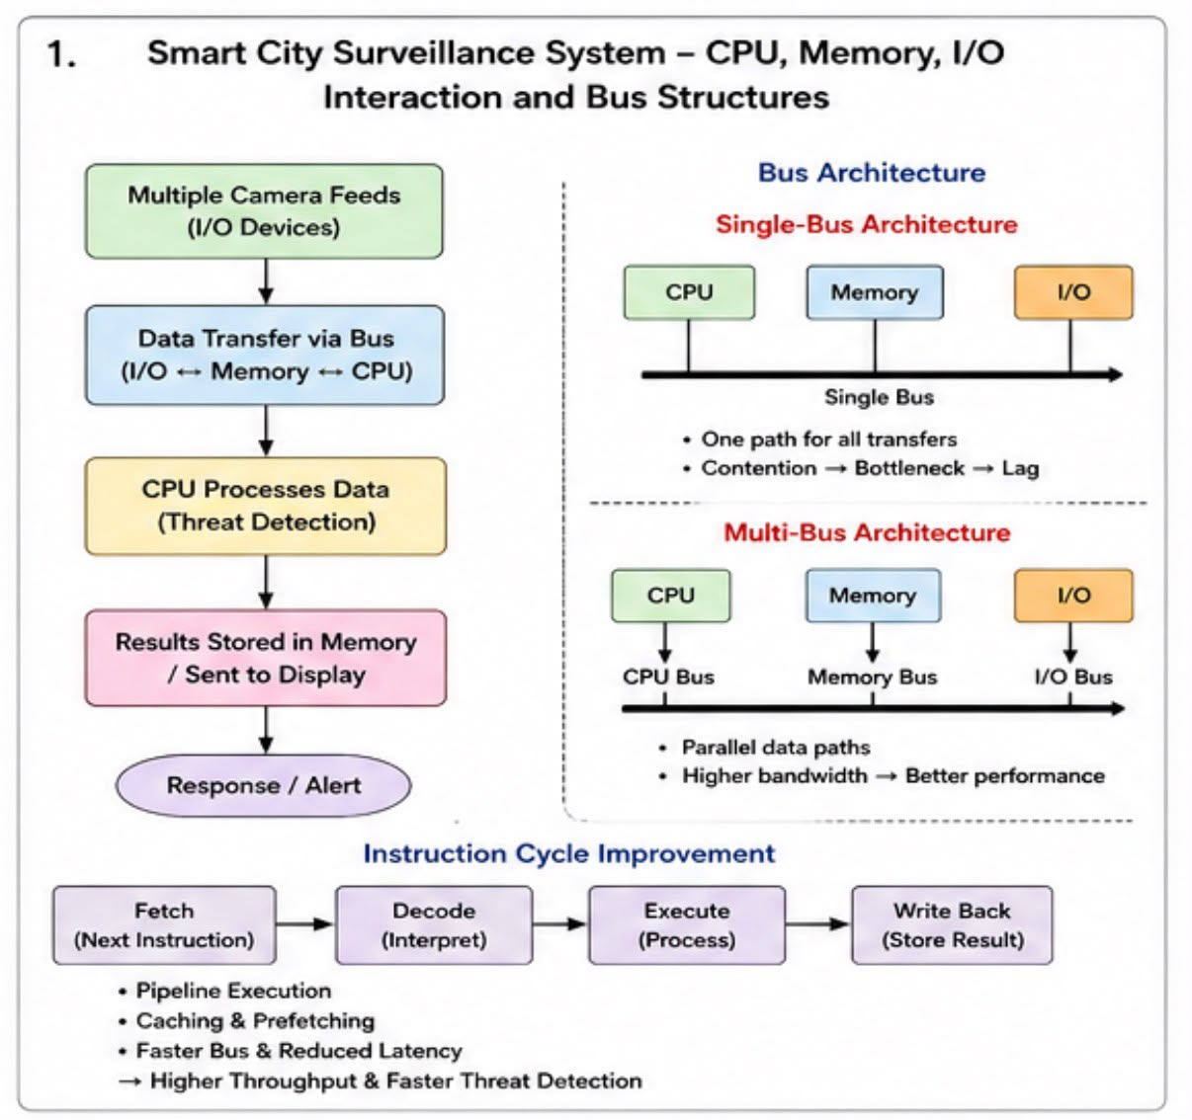

Question 2

Impact of the Fetch–Decode–Execute Cycle on CPU Performance in a Real-Time Stock TradingSystem
Identify:
The major components involved in the execution of the stock trading system are:
- CPU (Central Processing Unit): Executes trading algorithms and processes transactions.
- Memory (RAM): Stores program instructions and trading data.
- Cache Memory: Holds frequently accessed instructions and data for faster access.
- Branch Instructions: Used for decision-making (e.g., Buy/Sell conditions).
- Clock Cycle: The basic time unit used by the processor to execute instructions.
- CPI (Cycles Per Instruction): Average number of clock cycles required to execute one instruction.
The delay occurs because the processor spends extra clock cycles accessing memory and handling branch instructions.
Analyze:
The processor executes every instruction using the Fetch–Decode–Execute Cycle.
1. Fetch Stage
- The CPU fetches the next instruction from memory using the Program Counter (PC).
- If the instruction is not available in cache, the CPU waits for data from RAM.
- Frequent memory access increases execution time.
2. Decode Stage
- The Control Unit decodes the instruction.
- It determines whether the instruction is arithmetic, logical, memory access, or branch instruction.
3. Execute Stage
- The ALU performs calculations or logical operations.
- Branch instructions may change the program flow.
4. Memory Access Stage
- Data is read from or written to memory.
- Memory access is slower than register access.
5. Write Back Stage
- The result is stored in the destination register.
- The next instruction begins execution.
Impact on Execution Time:
During high trading activity:
- Millions of instructions are executed every second.
- Frequent RAM access causes memory stalls.
- Branch instructions create pipeline hazards.
- The CPU waits for memory and branch decisions.
- Overall CPI increases, leading to slower transaction processing.

Compare:
Feature | High CPI System | Optimized Low CPI System
Memory Access | Frequent RAM access | Mostly cache access
Branch Prediction | Poor | Accurate
Pipeline Stalls | More | Less
CPU Waiting Time | High | Low
Execution Speed | Slow | Fast
Throughput | Low | High

Calculate :
CPU Performance Formula
$$\text{CPU Time}=\text{Instruction Count}×\text{CPI}×\text{Clock Cycle Time}$$
Given
- Instruction Count = 10,000,000
- CPI = 2.5
- Clock Cycle Time = 0.4 ns
Before Optimization
$$CPU Time=10,000,000×2.5×0.4ns \\ CPU Time=10,000,000ns=10ms$$
After Optimization
Suppose architectural improvements reduce CPI to 1.5
$$CPU Time=10,000,000×1.5×0.4ns \\ CPU Time=6,000,000ns=6ms$$
Performance Improvement
$$\frac{10-6}{10}×100=40\%$$
Execution time is reduced by 40%, improving transaction speed.

Evaluate:
The major reasons for high CPI are:
- Frequent memory access increases waiting time.
- Branch instructions interrupt pipeline execution.
- Cache misses force CPU to access slower RAM.
- Pipeline flushing wastes processor cycles.
Among these, memory latency and branch misprediction have the greatest impact on processor performance in a real-time stock trading application.

Recommend / Design:
The following architectural improvements are recommended:
1. Cache Memory
- Increase L1 and L2 cache size.
- Reduce RAM access.
2. Branch Prediction
- Predict branch outcomes accurately.
- Reduce pipeline flushing.
3. Instruction Pipelining
- Execute multiple instructions simultaneously in different stages.
4. Superscalar Processor
- Execute more than one instruction per clock cycle.
5. Out-of-Order Execution
- Execute independent instructions while waiting for memory.
6. Larger Register File
- Store more temporary data inside CPU registers.
- Reduce memory accesses.
7. Prefetching
- Load instructions into cache before they are needed.
These improvements lower CPI and significantly improve processor performance.

Justify:
The recommended techniques improve performance because:
- Cache memory reduces memory access delay.
- Branch prediction minimizes incorrect pipeline execution.
- Instruction pipelining increases instruction throughput.
- Superscalar architecture executes multiple instructions simultaneously.
- Out-of-order execution keeps the CPU busy instead of waiting for stalled instructions.
- Prefetching ensures instructions are readily available in cache.
Therefore, these architectural enhancements reduce CPI, decrease execution time, and enable faster transaction processing under heavy trading loads.
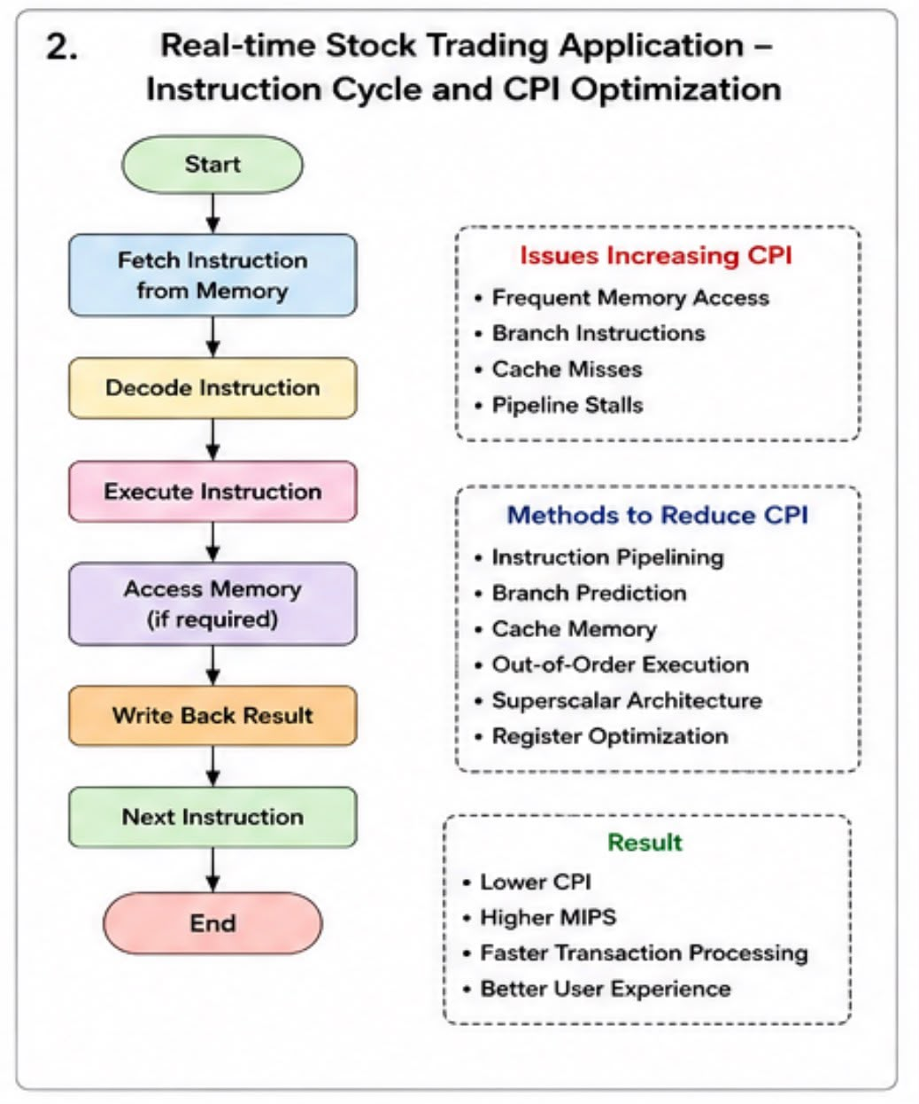

Question 3:
Embedded System Based on 8085 Microprocessor
Identify:
The industrial temperature control system occasionally processes incorrect temperature readings because of the improper use of addressing modes in the program.

Analyze:
The 8085 microprocessor supports several addressing modes:
- Immediate Addressing: Data is part of the instruction.
- Register Addressing: Data is stored in CPU registers.
- Direct Addressing: Uses a fixed memory address.
- Register Indirect Addressing: Memory address is stored in a register pair (HL).
- Implied Addressing: Operand is implied by the instruction.
Incorrect selection of an addressing mode may cause the CPU to read incorrect sensor values.

Compare:
Addressing Mode | Advantage | Limitation | Suitable Use
Immediate | Fast | Cannot access sensor memory | Constants
Register | Very fast | Limited storage | Temporary data
Direct | Simple | Fixed memory location | Fixed sensor addresses
Register Indirect | Flexible | Requires correct HL value | Arrays and sensor buffers
Implied | Simple | Limited instructions | Internal operations

Calculate :
Example:
Sensor temperature stored at memory location 2500H
Correct instruction:
LDA 2500H
If the programmer mistakenly uses:
MVI A,25H
Instead of reading the sensor value from memory, the accumulator stores the constant 25H, resulting in an incorrect temperature reading.

Evaluate:
Possible causes include:
- Incorrect addressing mode.
- Wrong memory address.
- Incorrect HL register contents.
These errors reduce system accuracy and may lead to incorrect actuator responses.

Recommend/Design:
To improve reliability:
- Use Direct Addressing for fixed sensor locations.
- Use Register Indirect Addressing for arrays or multiple sensors.
- Verify memory addresses before execution.
- Initialize registers correctly.
- Test the program using debugging tools.
- Add proper synchronization when reading sensor data.

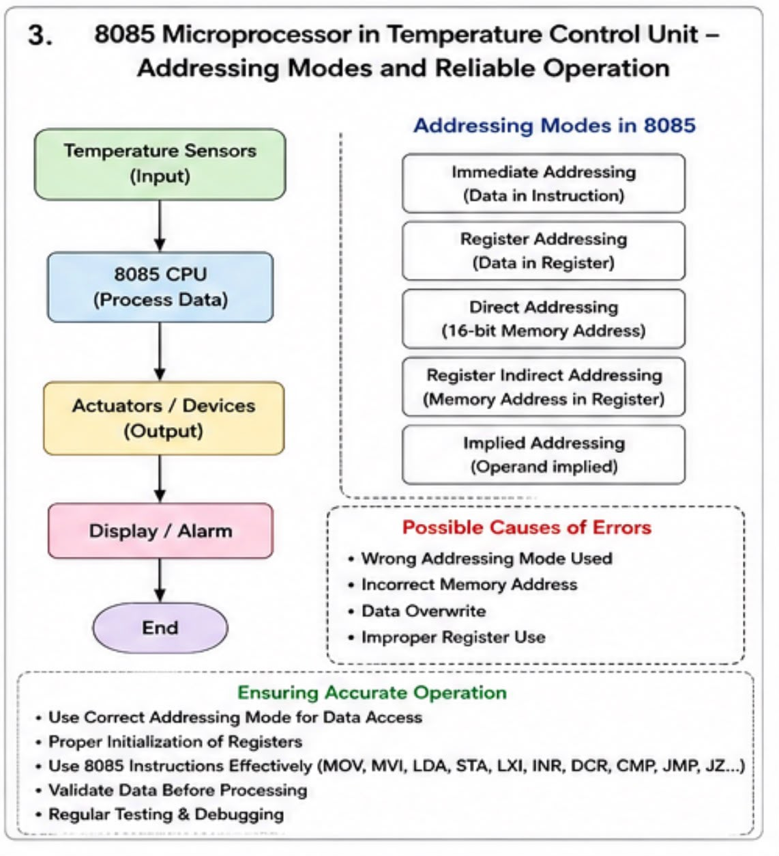

Question 4:
Segmentation in 8086 Microprocessor and Its Impact on Program Execution
Identify:
The 8086 microprocessor uses a segmented memory architecture to access its 1 MB memory space.
Memory is divided into logical segments, each having a maximum size of 64 KB.
The main segments are:
- Code Segment (CS): Stores program instructions.
- Data Segment (DS): Stores variables and data.
- Stack Segment (SS): Stores temporary data, return addresses, and register values.
- Extra Segment (ES): Used as an additional data segment.
Each segment works with an offset address to generate the physical address.
Physical Address = Segment × 10H + Offset

Analyze:
Proper segmentation ensures that each program accesses only its intended memory.
Working of Segments
Segment | Register | Purpose
Code Segment | CS | Stores executable instructions
Data Segment | DS | Stores variables and constants
Stack Segment | SS | Stores stack data for function calls
Extra Segment | ES | Additional data storage
When multiple programs execute simultaneously:
- Each program has separate CS, DS, and SS values.
- Context switching updates all segment registers.
- The CPU fetches instructions using CS:IP.
- Data is accessed through DS.
- Stack operations use SS:SP.
If these registers are not updated correctly, memory corruption occurs.

Compare:
Proper Segment Handling | Improper Segment Handling
Correct data access | Wrong data is accessed
Safe stack operations | Stack overflow/underflow
Programs remain isolated | Programs overwrite each other's memory
Correct instruction execution | Invalid instructions executed
Reliable multitasking | Program crashes

Calculate :
Suppose:
Code Segment (CS) = 2500H
Instruction Pointer (IP) = 1200H
Physical Address
= 2500H × 10H + 1200H
= 25000H + 1200H
= 26200H
Similarly,
Stack Segment (SS) = 4000H
Stack Pointer (SP) = 0100H
Physical Address
= 4000H × 10H + 0100H
= 40000H + 0100H
= 40100H

Evaluate:
Improper handling of segment registers causes several issues.
Incorrect Data Access
- Wrong DS value points to another program's memory.
- Variables become corrupted.
- Data read/write operations become incorrect.
Stack Overflow
- Stack grows beyond allocated space.
- Return addresses are overwritten.
- Function calls fail.
- System crashes may occur.
Wrong Instruction Execution
- Incorrect CS value causes execution of unintended instructions.
- Invalid opcodes may generate exceptions or unpredictable behavior.
Multitasking Problems
- Context switching without saving/restoring CS, DS, SS, and ES results in memory corruption between processes.

Recommend / Design:
To ensure correct execution:
- Assign separate Code, Data, and Stack segments to every program.
- Save and restore all segment registers during context switching.
- Allocate sufficient stack memory.
- Perform stack overflow checks.
- Initialize segment registers before execution.
- Use memory protection techniques wherever supported.
- Validate segment values before accessing memory.

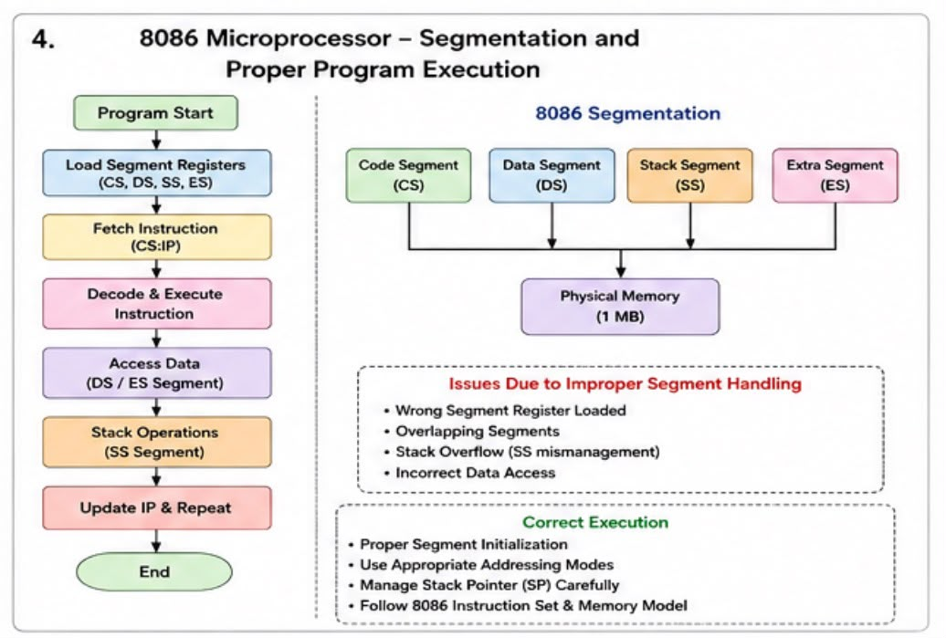

Question 5
Number System Conversion and CPU Benchmarking in Data Communication Systems
Identify:
Data communication systems commonly represent packet information in Hexadecimal (Base-16) because
it is compact and easy for humans to read.
However, CPUs process information internally in Binary (Base-2).
Therefore, accurate conversion between hexadecimal and binary is essential.
Analyze:
Each hexadecimal digit represents 4 binary bits (1 nibble).
Example:
Hexadecimal:
3A
Binary:
3 → 0011
A → 1010
Binary Value:
00111010
During packet transmission:
- Data is viewed in hexadecimal.
- CPU converts it into binary.
- Binary instructions are executed.
If conversion is incorrect:
- Wrong instructions may execute.
- Packet fields become invalid.
- Address calculations fail.
- Communication errors increase.

Compare:
Hexadecimal | Binary
Compact representation | Internal CPU representation
Easy debugging | Direct execution
Human-readable | Machine-readable
Fewer digits | More digits
Used in memory dumps | Used in arithmetic and logic

Calculate :
Example 1
Hexadecimal:
4F
Binary Conversion
4 → 0100
F → 1111
Result
01001111

Example 2
Binary
11100110
Grouping into four bits
1110 0110
Hexadecimal
E 6
Result
E6

Evaluate:
Incorrect hexadecimal-binary conversion affects the system in many ways.
Instruction Execution Errors
- CPU executes unintended instructions.
- Invalid opcodes may occur.
Incorrect Packet Processing
- Header values become corrupted.
- Wrong destination addresses.
- Transmission failures.
Data Corruption
- Incorrect payload interpretation.
- Checksum mismatches.
Security Issues
- Authentication values become invalid.
- Encryption/decryption failures.

Recommend / Design:
To reduce conversion errors:
- Use automated conversion libraries instead of manual conversion.
- Validate packet fields before processing.
- Perform checksum and CRC verification.
- Include exception handling for invalid hexadecimal values.
- Use standardized encoding methods.
- Test conversion modules thoroughly.
CPU Design Improvements
- Hardware-assisted hexadecimal-to-binary conversion.
- Error detection circuitry.
- Efficient instruction pipelines.
- Cache optimization.
- Parallel processing support.
Benchmarking Techniques
- Measure instruction execution time.
- Monitor CPU utilization.
- Evaluate packet throughput.
- Measure latency.
- Calculate error rates.
- Stress-test the communication system under heavy traffic.
